Criar um dashboard de vendas com os principais indicadores de desempenho e com os principais drivers dos resultados do mês

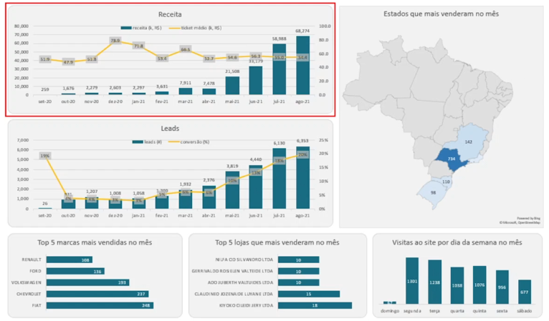

**Query 1 - Receita, leads, conversão e ticket médio mês a mês**

Colunas: mês, leads (#), vendas (#), receita (k, R$), conversão (%), ticket médio (k, R$)

**with**

leads **as** (

**select**

date_trunc('month', visit_page_date)::**date** **as** visit_page_month,

**count**(*) **as** visit_page_count

**from** sales.funnel

**group** **by** visit_page_month

**order** **by** visit_page_month

),

payments **as** (

**select**

date_trunc('month', fun.paid_date)::**date** **as** paid_month,

**count**(fun.paid_date) **as** paid_count,

**sum**(pro.price * (1+fun.discount)) **as** receita

**from** sales.funnel **as** fun

**left** **join** sales.products **as** pro

**on** fun.product_id = pro.product_id

**where** fun.paid_date **is** **not** **null**

**group** **by** paid_month

**order** **by** paid_month)

**select**

leads.visit_page_month **as** "mês",

leads.visit_page_count **as** "leads (#)",

payments.paid_count **as** "vendas (#)",

(payments.receita/1000) **as** "receita (k, R$)",

(payments.paid_count::**float**/leads.visit_page_count::**float**) **as** "conversão (%)",

(payments.receita/payments.paid_count/1000) **as** "ticket médio (k, R$)"

**from** leads

**left** **join** payments

**on** leads.visit_page_month = paid_month

**Query 2 - Estados que mais venderam**

Colunas: país, estado, vendas (#)

**select**

'Brazil' **as** país,

cus.state **as** estado,

**count**(fun.paid_date) **as** "vendas (#)"

**from** sales.funnel **as** fun

**left** **join** sales.customers **as** cus

**on** fun.customer_id = cus.customer_id

**where** paid_date **between** '2021-08-01' **and** '2021-08-31'

**group** **by** país, estado

**order** **by** "vendas (#)" **desc**

**limit** 5

**Query 3 - Marcas que mais venderam no mês**

Colunas: marca, vendas (#)

**select**

pro.brand **as** marca,

**count**(fun.paid_date) **as** "vendas (#)"

**from** sales.funnel **as** fun

**left** **join** sales.products **as** pro

**on** fun.product_id = pro.product_id

**where** paid_date **between** '2021-08-01' **and** '2021-08-31'

**group** **by** marca

**order** **by** "vendas (#)" **desc**

**limit** 5

**Query 4 - Lojas que mais venderam**

Colunas: loja, vendas (#)

**select**

sto.store_name **as** loja,

**count**(fun.paid_date) **as** "vendas (#)"

**from** sales.funnel **as** fun

**left** **join** sales.stores **as** sto

**on** fun.store_id = sto.store_id

**where** paid_date **between** '2021-08-01' **and** '2021-08-31'

**group** **by** loja

**order** **by** "vendas (#)" **desc**

**limit** 5

**Query 5 - Dias da semana com maior número de visitas ao site**

Colunas: dia_semana, dia da semana, visitas (#)

**select**

**extract**('dow' **from** visit_page_date) **as** dia_semana,

**case**

**when** **extract**('dow' **from** visit_page_date)=0 **then** 'domingo'

**when** **extract**('dow' **from** visit_page_date)=1 **then** 'segunda'

**when** **extract**('dow' **from** visit_page_date)=2 **then** 'terça'

**when** **extract**('dow' **from** visit_page_date)=3 **then** 'quarta'

**when** **extract**('dow' **from** visit_page_date)=4 **then** 'quinta'

**when** **extract**('dow' **from** visit_page_date)=5 **then** 'sexta'

**when** **extract**('dow' **from** visit_page_date)=6 **then** 'sábado'

**else** **null** **end** **as** "dia da semana",

**count**(*) **as** "visitas (#)"

**from** sales.funnel

**where** visit_page_date **between** '2021-08-01' **and** '2021-08-31'

**group** **by** dia_semana

**order** **by** dia_semana